Project Proposal: TERRA – Tracking and Environmental Real-time Response Apparatus
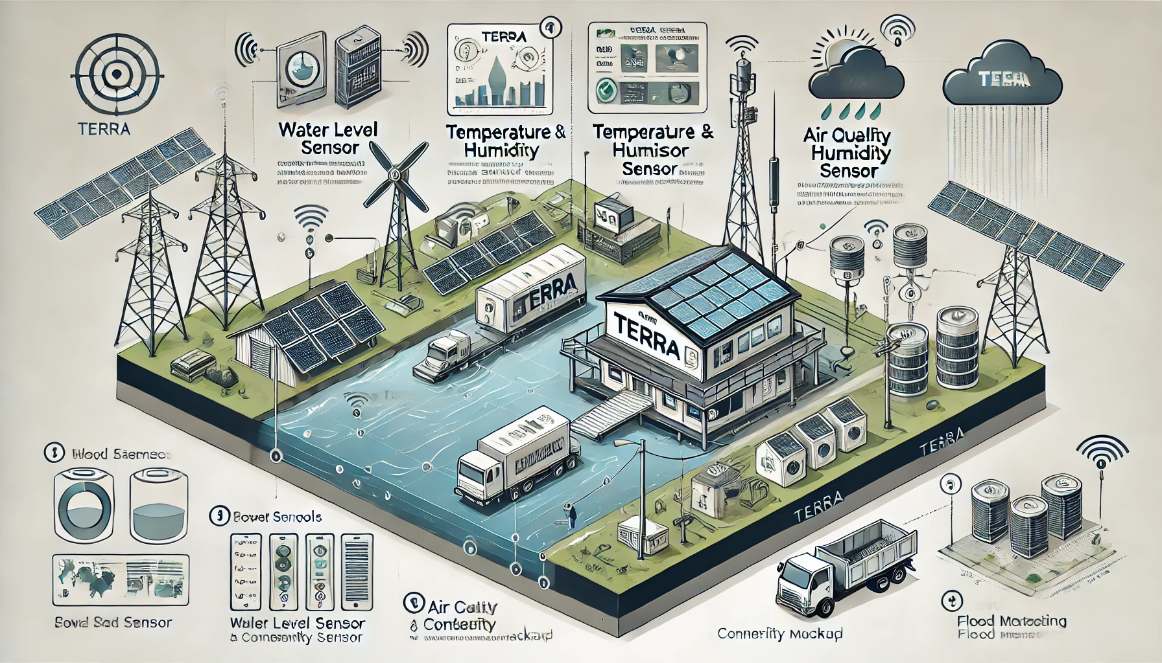
Objective:
TERRA seeks to redefine flood management and environmental monitoring in Bangladesh, aligning with SDG 11 (Sustainable Cities and Communities). By delivering immediate, precise data to authorities, TERRA enhances decision-making in flood-prone regions, enabling faster, targeted responses to minimize risk and protect communities.

Project Overview
TERRA, the Tracking and Environmental Real-time Response Apparatus, is an automated, real-time flood management device providing critical environmental data directly to decision-makers, bypassing the delays common with citizen-reported systems. Each TERRA device is equipped to function seamlessly across Bangladesh’s varying connectivity and power landscapes, establishing a resilient, scalable, and adaptable solution to flood management.

Key Features
- Automated Environmental Sensing:
Each TERRA unit autonomously monitors critical flood indicators, including water level, temperature, humidity, and air quality. The successful prototype demonstrates TERRA’s capacity to capture this data in real-time, reducing the need for manual intervention and offering reliability in flood-prone environments.
- Flexible Connectivity Options:
TERRA is optimized for diverse infrastructure conditions in Bangladesh, supporting multiple connectivity options, such as Wi-Fi, GSM, and LoRaWAN, to ensure uninterrupted data transfer from even the most remote locations.
- Resilient Power Options:
Designed for power consistency, TERRA supports solar power, battery, and AC/DC backup, maintaining functionality through extended flood events and power outages.
- Real-Time Data Visualization and Alerts:
TERRA’s centralized dashboard provides instant situational awareness to decision-makers. Data from each unit is visualized on a geographic map, enabling swift, localized responses. Automated alerts and real-time data feeds offer predictive insights that support proactive flood management.
- Future Expansion with Additional Sensors and Prediction Models:
Based on initial success, TERRA’s platform is set to expand with further environmental sensors and predictive models. Our goal is to provide decision-makers with comprehensive situational awareness across Bangladesh—from soil conditions to river water quality. This expansion will enable informed agricultural and economic decision-making, bolstering both regional food security and economic resilience.

Advantages Over Traditional Flood Prediction Systems
TERRA surpasses traditional flood prediction models with its decentralized, real-time sensing network and adaptive infrastructure design. Unlike models reliant on historical data and forecasts, TERRA provides live, region-specific data that enables authorities to respond precisely, especially in dynamic flood scenarios such as flash floods. TERRA’s adaptability to Bangladesh’s connectivity and power limitations ensures consistent performance in locations where traditional systems might fail.

Technical Specifications
- Core Sensor Array
  - Flood Indicators: Ultrasonic and pressure sensors for water level monitoring
  - Environmental Conditions: Temperature, humidity, barometric pressure, and air quality sensors
- Data Transmission and Processing:
  - Supports Wi-Fi, GSM, and LoRaWAN for maximum connectivity options.
  - Cloud-based centralized dashboard aggregates and visualizes data for remote management.
- Power Systems:
  - Solar panels, battery backup, and AC/DC conversion for continuous operation.

Impact and Relevance to SDG 11
By equipping decision-makers with real-time insights, TERRA supports sustainable urban resilience:
- Enhanced Responsiveness: Decision-makers can assess flood conditions instantly, optimizing resource allocation.
- Economic Protection: Preemptive alerts reduce social and economic losses by enabling swift preventive action.
- Local Resilience: Data-supported infrastructure planning directly strengthens rural and urban resilience.

Prototype
The TERRA prototype is a compact environmental monitoring unit specifically designed for flood-prone areas. Here’s a breakdown of how it operates and the components used:
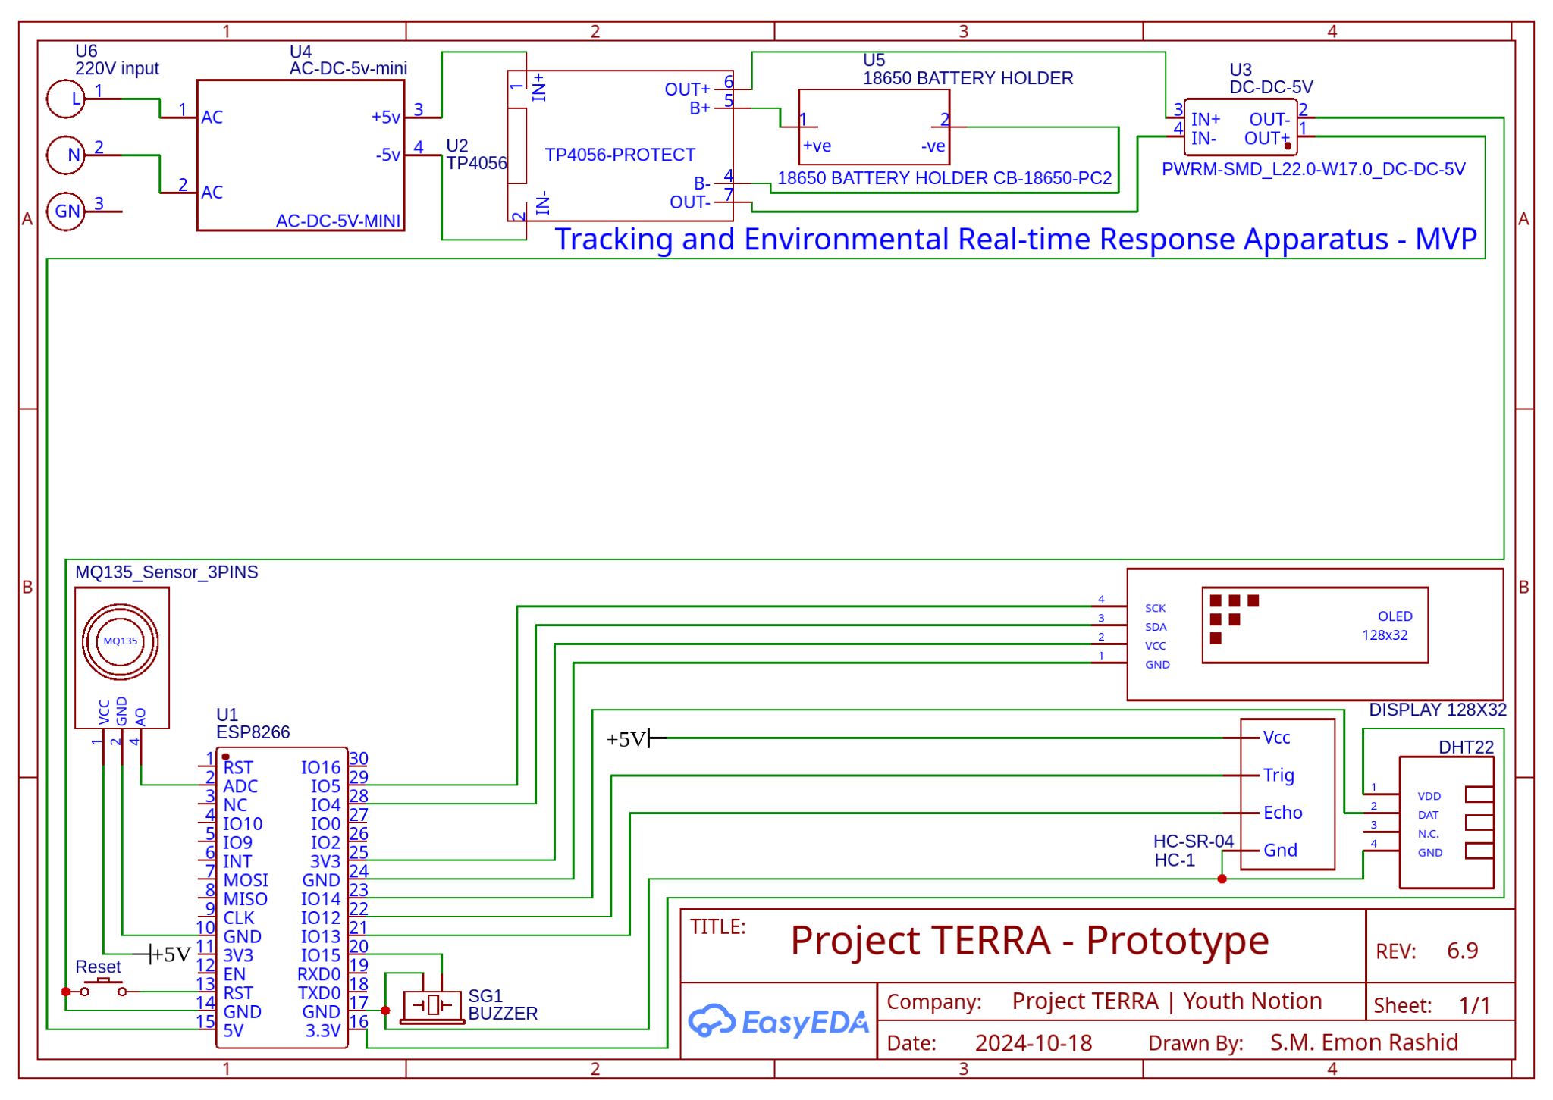

1. Core Microcontroller and Connectivity
- ESP8266 Microcontroller: This Wi-Fi-enabled microcontroller serves as the system's main processing unit. It collects data from various connected sensors, processes this information, and transmits it via a Wi-Fi network to a central server for analysis and storage. This Wi-Fi-based connection eliminates the need for a 4G module in this initial prototype but limits deployment to areas within Wi-Fi range.

2. Sensors and Data Collection
- DHT22 Sensor: The DHT22 sensor monitors temperature and humidity levels, providing accurate readings essential for assessing weather conditions and air moisture content, which are critical for understanding pre-flood atmospheric conditions.
- HC-SR04 Ultrasonic Sensor: This sensor measures water levels in real-time by emitting ultrasonic waves that bounce back when they hit a surface (such as water). By calculating the time it takes for the waves to return, the device estimates water height, helping detect rising water levels that may indicate an imminent flood.
- MQ135 Air Quality Sensor: The MQ135 sensor detects the presence of pollutants and gases in the air. Changes in air quality can indicate shifts in environmental conditions often associated with disaster-prone weather, allowing the device to provide early warning signals or detect the aftermath of flood-induced pollution.

3. Power Management and Storage
- TP4056 Battery Management System (BMS): This BMS is used to regulate power flow to the system, ensuring that the 18650 battery charges efficiently and provides consistent power without over-discharging.
- 18650 Battery: This rechargeable lithium-ion battery is connected to the BMS, providing a reliable power source for remote deployments where electricity supply is inconsistent. Additionally, a DC-DC boost converter ensures stable voltage for the components, further enhancing the system’s reliability.
- AC to 5V DC Adapter: Where AC power is available, this adapter supplies power directly to the system, charging the battery and powering the device.

4. Data Transmission and User Interface
- Once the ESP8266 processes the sensor data, it uses Wi-Fi to send this information in real-time to a central server. This central server compiles, analyzes, and visualizes data, allowing decision-makers and flood response teams to access real-time environmental insights on a dedicated platform or dashboard.
- The initial prototype includes a basic I2C OLED display, providing local readouts of key metrics for field operators or maintenance personnel to monitor system status without requiring external devices.

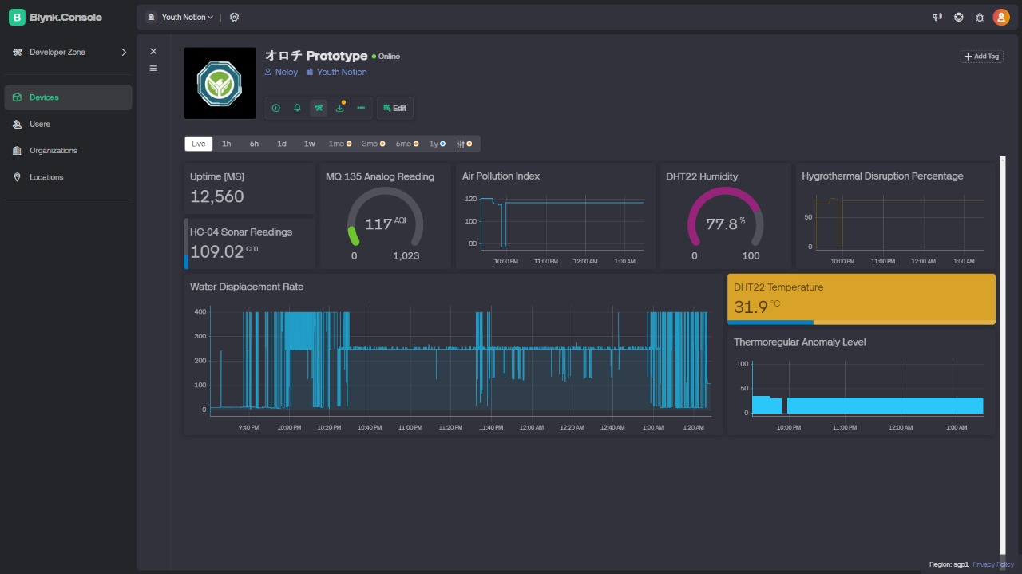

Conclusion
As a powerful alternative to conventional flood prediction models, TERRA represents a transformative step in flood management. The current prototype successfully captures water level, temperature, humidity, and air quality in real-time, providing high utility for immediate flood response. By incorporating additional sensors and predictive modeling, TERRA aims to expand its utility beyond flood management, supporting better-informed decisions in agriculture and economic planning. In deploying TERRA, Bangladesh can lead in environmental resilience, protecting communities and fostering sustainable development.

